REVIEW OF CP22/07 -FCA FEE INCREASES

Summary
Changes that were proposed have been considered and the FCA have decided on much the same approach, but are now phasing this in over four years instead of three.
If current RPI inflation at 11.1% per annum continues, this will erode the impact (ie purchasing power of the pound) by a 68% over a period of five years. Or to put this another way, firms can expect their turnover numbers to increase by this amount just to stand still, in relative terms.

First point to note, relevant only to financial advisers, is that the FSCS levy is excluded – even though the FCA collect this fee on behalf of the industry.
The FCA initially estimated increase requirements of 4.3%. After this consultation they reduced this to 2.8% mainly by reducing their ambitions in the immediate future.
Movers and shakers in the fee blocks:
- FCA have all but pulled plans for further AML programs with a 44.3% reduction in funding and restructuring the cryptocurrency costs application.
- Percentage wise the hardest hit is an increase of over 45% for credit rating agencies and repositories and building societies were not giving further comment on this sector.

FCA increases to minimum fees for “A” and “CCL” blocks
It is interesting to note that the FCA board implemented these increases in March 2022 prior to the publishing of CP22/07 (So any consultation was worth about as much as a Greek Government bond!) However the critical responses mean that they have been forced to implement changes to the CP post implementation.
What they are keeping:
- Duel regulated firms - reduction of FCA costs by 50% as they pay on prudential side too.
- Application of 25% (medium impact) and 65% (High impact) increases to top two banks of “A” block – deposit acceptors
- Kept the banding risk structure for charging firms that holding client money
- EEC firms fees will be maintained as they transition out.
- Rightly a complaint in terms of industry wide recovery of costs for cryptocurrencies project and its evident failure.
FCA responses have included:
- “We froze costs for the two years of covid” -ie what more do you want?
- “We have strong processes and controls in cost savings” – which is an interesting claim.
- They have increased the implementation period from 3 to 4 years
To this end here are the visual changes to the implemented A and CC blocks:
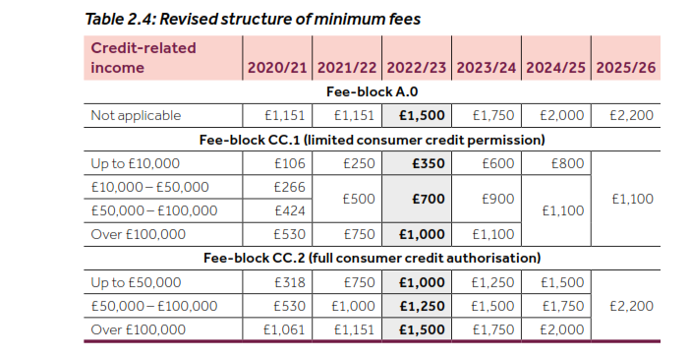
- However no freezing possible fee reviews and all bets are off after 2025.
- Reading between the lines – they won’t implement polluter type charging as the FCA costs are way beyond what the polluting firm could pay. So is the FCA value for money?
- No to extended terms of payment – To do this would effectively cost the FCA more to administer.

